Research of the graduate’s quality evaluation methods of university's undergraduate

Wei Wu

College of Earth Sciences
Daqing Petroleum Institute
Daqing
Hei Long Jiang
China
100044

Telephone：
+86-459-6503759
+86-13936901343

Preface
The university’s contribution to the economic development and social progress , to a great extent ,will be realized by many groups of graduates with both good character and fine scholarship. Quality of the graduates cultivated by the universities is essential for both themselves and the society. How to appraise the graduate's quality of university's undergraduate, what the appraising standard is, and adopt which appraisal methods, are the concerns of higher education administrator, higher educators and the generally concern of society.
The graduates are the main “products” cultivated by the universities. The quality of “products” have direct relation with the existence and development of the university. In term of this, it is the same with enterprise, products’ quality is the lifeblood of enterprises, and the enterprises’ product quality evaluations have ripe and perfect criteria and methods. But the appraisal of graduate's quality of undergraduate course is much more complicated. Famous foreign universities have their own evaluation criteria, such as Yale University whose goal is training the leaders of each field. Their appraisal content to the graduate are, the leaders of various fields, the number of people who win the Nobel Prize, the graduates’ average annual pay, the graduates’ effect to the society and even to the mankind, etc., Some studies, such as Graduate Student Exit Survey Results and Northwestern’s Graduate Students: Perspectives on Academic and Student Life, choose follow indicators to evaluate students: the natural statistics characteristic, economic situation, situation of student applying for the scholarship, loaning or not at school, education background, goal of the present graduate's personal plan for education, present job state, the effect of using these resource of the university to seek jobs and promotion, quality of the university’s service facility, different and specialized, native and foreign student's satisfaction to the university, etc .There are also special social intermediary and research institution do the graduate's appraisal research, such as Division Of Student Affairs And Institutional Research by NU pulse and Graduate Student Quality of Life Survey by Center for Survey Research Stony Brook University. Their main evaluation index contains the investigation of the student's state, students’ satisfaction to the course, activity center, accommodation, scholarship. The investigation usually regard student of second institute as respondents, and sometimes count the proportions of men and women separately too.
At present, there is no systematic graduate's quality evaluation index system and appraising method in China. Establishing and perfecting the graduate's appraisal system not only directly concerns the evaluation in graduate's employment quality, but also have important impacts on enrollment structure and the university’ s training work, so it is very meaningful to engage in this research.

Study Background

Development of higher education of China in the 21st century
After reform and opening-up, China has made remarkable achievement in educational field, higher education has realized the historical leap，the gross entrance rate was up to 15% in 2002, which making higher education of China enter the internationally acknowledged mass education stage. The running of the university faces new situation: the economic globalization is bound to promote the internationalization of higher education; the development of the knowledge and economy must promote the demand for knowledge and talent, intensify the competitions of science, technology and talents, so the university must provide creating education and the cultivation of innovative talents. The information-based society will inevitably promote the informationization of higher education, life-long education and learning-oriented society must change the social attitude toward study and requirement for talent. The university must offer the foundation for life-long education in order to make students have the ability of life-long learning; human-oriented and training the all-round developing person will accelerate the change of old educational method and conception. Under the background of the education reform, in order to further deepen the reform of higher education, Ministry of Education has introduced the developing plan of higher education and implemented the reform project of higher education. The project of “research of graduates’ quality evaluation method of university undergraduate” stems from new century higher education reform project (the second issue) of Heilongjiang Province. It was from November of 2003 to November, 2004 that the project was studied.

Basic Thought of Graduate's Quality Evaluation

Evaluation principles
Composition of graduates’ quality evaluation system should consider the concrete stage of social development and the progress of higher education reform. At first, the market principle and the direction of running a socialist school should be combined. It is unscientific to imitate the evaluation system of the developed western countries and to emphasis on Chinese specific characteristics too much. For example, the graduate EC sub-plans ignore the differences between graduates, and the assessment system of Western countries emphasizes too much on student self-realization. Secondly, the work itself and the employment result should be combined. In the past, evaluation of the graduates’ employment was often evolved into evaluation of employment itself in our country, while evaluation system of Western countries simply considered the employment results. As a result, it is difficult to totally reflect that universities take the employment seriously. In fact, a perfect employment system not only directly influences and promotes the graduates’ employment quality, but also plays an important role in facilitating and promoting students’ study and growth in school.

Combine scientific with fair
Being scientific is the foundation of the existence and development of any evaluation system. Unscientific evaluation is of no value, but misleads the public. Fairness ensures that the evaluation can be carried on smoothly, and unfair evaluation will have a direct impact on the scientific and justice of the evaluation results. At present, it is not scientific enough to evaluate graduates only by the employment rate, and the source of the data only can be obtained through their college. Fairness is unable to be guaranteed.

Combine subjective with objective
The evaluation of graduates can adopt the principle of combining the subjective indexes with objective indexes. Some indexes, such as employment rates, supply –demand ratio and the average beginning salary, etc, can be used as objective evaluation indexes. And social contribution, social reputation, enterprises’ satisfaction, and other indicators can be used as subjective evaluation indexes. Objective indexes should be used as many as possible, these indicators can be obtained through adopting sampling surveys by social intermediary organizations.

Combine indicators of this year with indicators of the calendar year
The evaluation of graduates should adhere to the principle of combining the year indicators with ones of the calendar year. Of course, indicators of this year, such as employment rate, supply and demand ratio, the average beginning salary, are easy to obtain, while graduates’ salaries after their a few years graduation, the value created for the society.etc are more difficult to obtain. But these indicators are indispensable and important for graduates’ quality evaluation system.

Combine expert opinions with that of the public
Owing to experts’ long-term track and research, their suggestions are more profound and comprehensive. The evaluation of the graduates often need to refer to the advice of employers, the public and even graduates themselves. So adherence to the combination of expert advice and public views will make the evaluation more comprehensive.

Basic idea of evaluation
While conducting the graduates’ quality evaluation, in accordance with the evaluation indexes, we can obtain evaluation information from various aspects. For example, when graduates are leaving school, we can gain information from the school, such as outstanding graduation project thesis, postgraduate qualifying examination rate, passing rate of College English Test Band 6 (CET-6 for short), the award obtained in the contest, scientific and technical result and publish thesis, patent, etc. After students’ graduation, the information, such as employment rate, supply and demand ratio, the average beginning salary, social reputation and social contribution, and something else, can be obtained from different social fields. All of these factors have different impact on the graduates’ comprehensive quality. These factors are known, yet the graduates’ comprehensive quality is unknown. In order to realize the quantitative description of graduates’ comprehensive quality, we can regard graduates’ comprehensive quality as a gray system, and according to the gray system theory, select employment rate , supply and demand ratio, the average beginning salary, social reputation and social contributions, etc, utilizing gray correlation analysis method to make the Gray Comprehensive Quality System into white. Through this method ,we can not only make a quantitative description and comparing of the development tendency and changes of the job situation of various professional graduates, but also confirm the related coefficient and related degree between the comprehensive quality evaluation index of graduate’s and the real data, then appraise the graduate’s comprehensive quality according to the information mentioned above.

Setting-up of graduate's quality evaluation index system of university's undergraduate

Evaluation index when graduates leaving school
The seminar studies and shows that there are mainly two aspects about graduate's quality evaluation index of the undergraduate: first, the quality evaluation index, while students are leaving school, Second, to confirm the quality evaluation index after graduates’ graduation for ten years, depending on the approval of the social employing unit, through the feedback of the talent market, to confirm the quality evaluation index after graduates’ graduation for ten years.

When graduates leaving school, the quality evaluation indexes are as follows

Outstanding graduation project thesis
Graduation project is the comprehensive appraisal to the cultivation quality of undergraduate, the comprehensive check of the student’s ability to employ the theory knowledge studied to analyze and solve problem under the guidance of tutor and overall examining of their ability of creativity, innovation. This index expresses with the percentage of the outstanding graduation project thesis when appraising.

Postgraduate qualifying examination rate
The percentage of the current year's graduate admitted to be the postgraduate, this is an important index of appraising the teaching quality of the undergraduate course.

The passing rate of CET-6
General university students' English level demands to reach CET-4 grade, the students whose English are in the CET-6 level, have higher ability of speaking, reading, writing, translation etc. Such abilities objectively reflect the high quality of graduates.

The award obtained in the contest, scientific and technical result
The award not only reflects students’ talent and potential in certain scientific field, but also reflects the academic level of students' school and the students’ initiative spirit and innovation ability in certain extent.
Publish thesis, patent
It’s an important index when appraising student's research results.

The evaluation index of graduates after their graduation for ten years
The evaluation indexes of graduates after their ten years’ graduation are as follow:

The employment rate
The direct yardstick of the quality of graduates is the signing and employment amount with the employing unit, express with the percentage. Ministry of Education counts and announces the employment rate of the subordinate university since 1999, it plays a very good role in the employment problem which society and university pay close attention to. Because college graduates overall are in short supply, so nationwide higher employment rates tend to mask the fact that the employment quality of graduate is not very high, the mismatch of people and job still remains. It’s a problem they should be also pay attention to.

Supply and demand ratio
The total demand number of social employing units for school leavers to the total number of graduates is the supply and demand ratio. For example, the supply and demand ratio of Fu Dan University in 2001 was up to 16:1, the supply and demand ratio of graduate students is as high as 27:1, and it reflected the good reputation of Fu Dan University in the society. Of course, the ratio has great difference between different speciality inside the school .

Average beginning salary
Average beginning salary is a common evaluation index of graduate's quality in foreign countries .The average beginning salary of the graduates in different universities and colleges, can reflect graduate's competitive ability on the market favorably. Certainly, average beginning salary of graduates in each speciality also has difference inside the school. In Liberation Daily on April 2004 16, the correspondent Qiu Yin reported that Shanghai Labor Insurance Bureau yesterday released the guide prices of salary of 100 positions, the foundation of the salary research is some graduates in 2002 in Shanghai (including the doctor, the master, undergraduate course, and junior college, their pretax income of the whole year in 2003 in Shanghai involve 100 positions such as managing ,professional technique, service skill and production skill. Income of the professional and technical personnel is higher than the common administrative staff , the average annual pay of the former kind is up to 30865 Yuan. The salary of software technical staff and communication engineering are higher, their average annual pay is close to 40,000 Yuan. Compared with this, as the managing position needs experience accumulated for a long time, so wage level is relatively low in the first year, generally only 20,000 Yuan. Salary of the doctor, postgraduate, the undergraduate, and junior college student are respectively 61061 Yuan, 48433 Yuan, 30817 Yuan, and 23909 Yuan.

Social reputation
It’s an important reference for appraising the graduate The information can be got through the measure of sample investigation by the social intermediary,

Social contribution
Appraising the social and economic development and the technological progress is also an important index of graduate's quality, the evaluation index of the social contribution including:
The employment quantity of graduate in the world 500 top enterprises; 500 top enterprises selected is the current international measure of the strength of enterprises, the graduate obtaining job in the 500 top enterprises is usually outstanding. The employment number of the graduates in the 100 strong enterprises in China; Number of the graduate self-employed; Self-employed contribution is also very large, it needs graduates to have enough courage and professional knowledge to become self-employed, therefore the statistics data has great significance .In addition , the statistics can also be the amount of the output value created by their company or the company they have major management ; Number of people in the important leading position.
These four mainly consider that graduates occupy the important position in society, bear more important community responsibility.

Pace of becoming a useful person
Take the time factor into account, different speciality takes different time in becoming a useful person.

Health factor
At first, physical condition of graduate should make them competent for the work they undertaking and the graduate's life-span should be considered at the same time.

Foundation and quantitative study and evaluation of mathematical model

Theoretical foundation of gray systematic, calculation formula
According to gray systematic theory, take all contestant specialties as a gray system, each speciality is regarded as a factor in the system, basing on the evaluation indicators demand, to build a contestant indicators than graduates of the " ideal graduate "as a reference series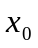，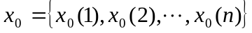 , to join each evaluation index of contest graduates as comparing series，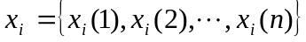 ,among them N is the evaluation index. Calculate the correlation between the contestant graduates and "ideal graduates "in the system..The calculation formula is:
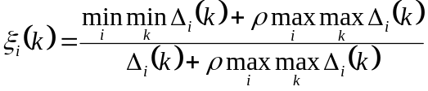 （1）
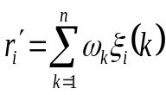 （2）
Where, 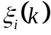 is the related coefficient; 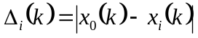for the absolute difference between the series and the series ; 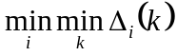 is second minimum difference; 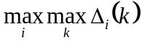 is second greatest difference; —distinguish coefficient, the fetching value is 0.5; 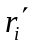—weighted coefficient; 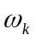— weight of the coefficient of each index.

Construct “ideal graduate” models
Every evaluation index of “ideal graduate” should correspond to evaluation indexes of all graduate and get the optimum value, i.e. the best “ideal state ", thus construct the quantization average of the quality evaluation index of the contestant graduate. Among them the fetching value of every evaluation index can be actual value or percentile.

Non-dimensional treatment of the data
Set ideal data as, have non-dimensional treatment of the data in table 1, that is use to removerespectively, the data are compressed in block [0, 1].

Calculate related coefficient, related degree
Take " ideal graduate "（）as consult series, other contestant graduates（）as comparing series, calculate related coefficient. I.e. at first obtain the absolute difference between the corresponding pointsand (i=1, 2, …,10; k=1,2, …,5), then try to get the related coefficientof each valuation indexand,according to the formula (1).Then obtained the weighted association between contestant graduates and " ideal graduates " by the formula (2), precedence happens side by side.

Related analysis —Appraising result analysis
Result that calculated, the greater the coefficient is, the closer is the comparative series to the reference series, the better the integrated indicators are. To arrange each contestant speciality by the correlation size, we can obtain the quality evaluation of the contestant speciality

Quality evaluation when the graduates leaving school

Construct the ideal graduate

The definition of outstanding graduation project thesis
The percentage of outstanding graduation project thesis in all graduation project thesis in the current year, remove the symbol '%' when calculating;

Definition of postgraduate qualifying examination rate
The percentage of the current year's graduate admitted to be the postgraduate, remove the symbol ' %' when calculating;

Definition of the passing rate of CET-6
The ratio is the number of graduates passing CET-6 to the number of the total graduates;

Definition of the award obtained in the contest, scientific and technical result
Mathematics modeling, national electronic competition for the non- electronic specialities, national English contest for university student, etc., the value is: the number of award of national grade multiply 1 and plus the number of award of provincial or city grade multiply 0.5.

Definition of publishing thesis, patent
Publishing a thesis gets 10 points, applying a patent gets 10 points.

Giving a quantitative mark for the evaluation indexes by the expert
Because each evaluation index has different importance in evaluation process, so give each evaluation index different weighed value.
Outstanding graduation project thesis = 0.2;
Postgraduate qualifying examination rate = 0.2;
Passing rate of CET-6 = 0.2;
The award obtained in the contest, scientific and technical result = 0.3;
Published thesis, patent = 0.1 .
Thus construct quantities’ average of the quality evaluation indexes of the contestant graduate, as shown in table 1.

 | Number  of the contestant speciality | Outstanding graduation project thesis | Postgraduate qualifying examination rate | Passing rate of CET-6 | Award obtained in  the  contest | Thesis patent
Normal  graduate | 1 | 35 | 30 | 10 | 7.5 | 50
Normal  graduate | 2 | 20 | 38 | 18 | 10 | 90
Normal  graduate | 3 | 23 | 32 | 5 | 12 | 120
Normal  graduate | 4 | 10 | 2 | 0 | 6 | 130
Normal  graduate | 5 | 7 | 1 | 1 | 2 | 70
Normal  graduate | 6 | 17 | 4 | 21 | 3 | 0
Normal  graduate | 7 | 21 | 3 | 0 | 4 | 60
Normal  graduate | 8 | 25 | 17 | 2 | 6 | 40
Normal  graduate | 9 | 8 | 10 | 5 | 8 | 10
Normal  graduate | 10 | 9 | 7 | 21 | 11 | 20
Ideal graduate |  | 50 | 45 | 40 | 30 | 200
Table1 Quantities’ average of the quality evaluation indexes of the contestant graduate (When graduates are leaving school).

Analysis of quality evaluation
Based on the mathematical model above we developed a quality evaluation system of graduates. Utilizing quality evaluation system of graduates to calculate each index quantitively, to arrange each contestant index by the correlation size, the larger the correlation is, the better the comprehensive quality evaluation of graduates is .The main interface of quality evaluation systems of graduates is as shown in Fig. 1.
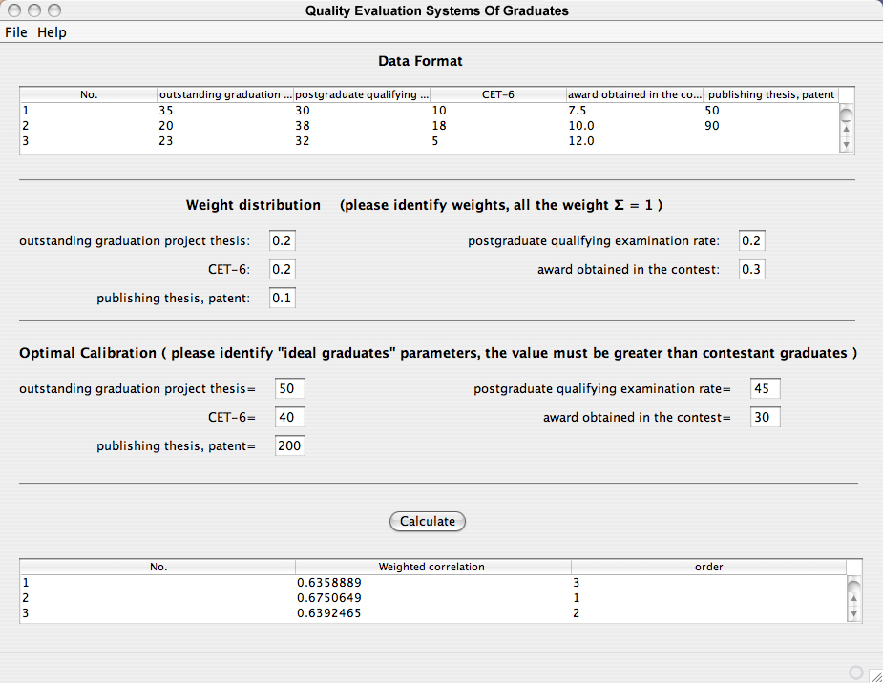
Fig.1 Main interface of quality evaluation systems of graduates (When graduate are leaving school)

Arranging each contestant graduate by the correlation size:
NO.2>NO.3>NO.1>NO.10>NO.8 >NO.6>NO.4>NO.9>NO.7>NO.5.It shows that NO.2 is the best and next NO.3…,and the worst is NO.5.

The quality evaluation after graduates’ graduation for ten years

Construct the ideal graduate

Definition of the employment rate
The signing rate when student are graduating, remove the symbol '%' when calculating;

Definition of supply and demand ratio
The total demand number of social employing units for school leavers to the total number of graduates;

Definition of the average beginning salary
Average beginning salary of certain speciality;

Definition of social reputation
To fetch 10 when very satisfied, to fetch 8 when satisfied, and fetch 0 when unsatisfied;

Definition of social contribution
The ratio is the number of the graduates who worked in 500 top enterprises in the world, in the 100 strong enterprises in China and the number of the graduate self-employed, the number of people in the important leading position to the total number of graduates.

Definition of the pace of becoming a useful person
Normal to fetch 1. Good-for-nothing to fetch 0, to fetch 0.7 between the two situations.

Definition of the health factor
Healthy to fetch 1, inferior healthy to fetch 0.5, working less than 10 years to fetch 0. Thus construct the quantization average of the contestant graduate’s quality evaluation index, see Table 2.

 | Number  Of the contestant speciality | Rate of employment | Supply and demand ratio | Average beginning salary | Social reputation | Social contribution | Pace of becoming a useful person | Health  factor
Normal  graduate | 1 | 100 | 10.0 | 1500 | 10 | 0.9 | 1 | 1
Normal  graduate | 2 | 100 | 12.0 | 1700 | 10 | 0.5 | 1 | 1
Normal  graduate | 3 | 100 | 9.80 | 1600 | 10 | 0.6 | 1 | 1
Normal  graduate | 4 | 95 | 1.30 | 1300 | 8 | 0.9 | 1 | 0.5
Normal  graduate | 5 | 97 | 0.25 | 1200 | 8 | 0.2 | 1 | 0.5
Normal  graduate | 6 | 79 | 0.67 | 800 | 0 | 0.1 | 1 | 1
Normal  graduate | 7 | 96 | 1.10 | 1200 | 10 | 0.7 | 1 | 1
Normal  graduate | 8 | 98 | 1.05 | 1200 | 8 | 0.5 | 1 | 0.5
Normal  graduate | 9 | 51 | 0.56 | 1350 | 8 | 0.0 | 0.7 | 1
Normal  graduate | 10 | 80 | 0.67 | 1475 | 0 | 0.3 | 1 | 1
Ideal graduate |  | 100.0 | 20.0 | 2000.0 | 10.0 | 1.0 | 1.0 | 1.0
Table 2 Quantities average of the quality evaluation indexes of the contestant graduate (working for ten years).

Giving a quantitative mark for the evaluation indexes by the expert
Employment rate =0.18;
Supply and demand ratio =0.25;
Average beginning salary = 0.17;
Social reputation = 0.15;
Social contribution = 0.15;
Pace of becoming a useful person = 0.05;
Health factor = 0.05.
The main interface of quality evaluation systems (quality evaluation after graduates’ graduation for ten years) of graduates is as shown in Fig. 2.
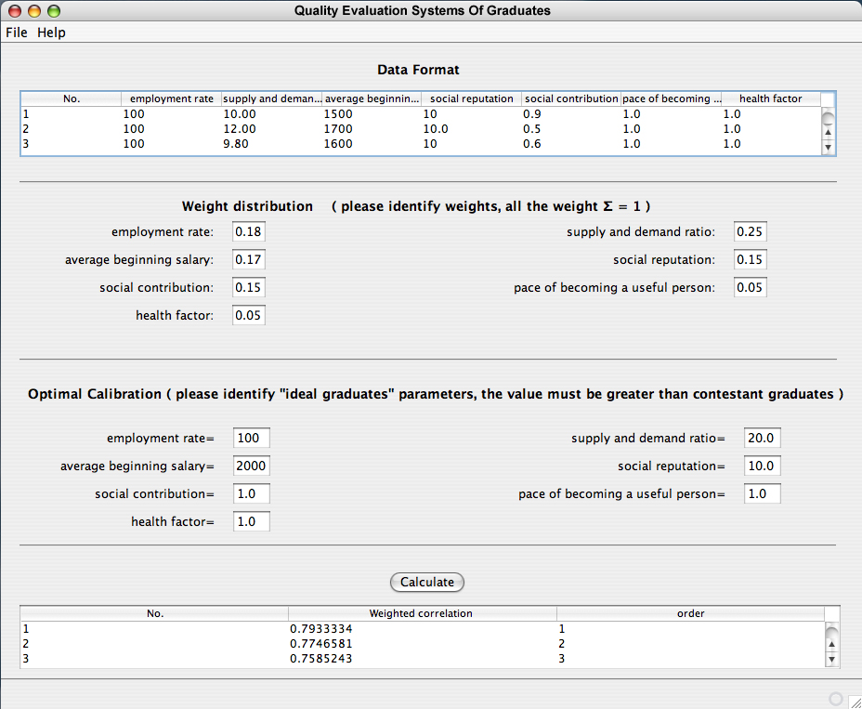
Fig.2 Main interface of quality evaluation systems of graduates
(Quality evaluation after graduates’ graduation for ten years)

Analysis of quality evaluation
Arranging to each contestant graduate by the correlation size: NO.1>NO.2>NO.3>NO.7>NO.4 >NO.8>NO.5>NO.10>NO.9>NO.6.It shows that NO.1 is the best and next NO.2…,and the worst is NO.6.

Conclusion and suggestion
There is extensive application of gray systematic theory in various comprehensive appraisal systems already, because there are a little data that gray related analytic approach needs, and does not consider the theoretical distribution of the data, calculation is also simpler and more convenient, it is apt to manage worker's knowing and application. In addition, " ideal graduates " constructed by this analytic approach has synthesized all fine information of the evaluation index of " quality" of graduates, thus it boosts the accuracy and validity of the evaluation of the contestant graduates .We can make comprehensive appraisal in synthesis " quality " of the contestant graduate according to the evaluation index requirement in resulting conclusion. So, this kind of method has certain use value in graduate's quality evaluation. For the assessment of graduates' quality, we must pay attention to tracking and accumulating. Really approval of a lot of graduates' value by the society takes some time, so graduate's quality evaluation is a long time job.
Graduate's quality evaluation method seminar of university's undergraduate course of Daqing petroleum institute, have already established the system of the evaluation index and the evaluation method through the research work for more than one year. As time is short, the work load is large, and we have not carried on further investigation on the application result of the established methods yet. So basing on the completed project, we fully utilize the conditions including: school running a school trade for a long time, the mostly graduates working in oil field and relevant industries, relatively centralized working range, so all these conditions make the follow-up investigation and get information of the growing up becoming a useful person easy. Then we will choose the same, close speciality of different universities after the 1990s, to obtain the graduate's actual information. And we can use the research results already got to carry on actual appraisal of graduate's quality of university's undergraduate. And combining the collection of the real data, we revise graduate's quality evaluation index of undergraduate that has already been set up, to make it more comprehensive, scientific and reasonable. The research work of this project is not merely meaningful in quality evaluation of the undergraduate course graduate, moreover, it also have reference function for the cultivation scheme of the undergraduate at school.

References
- Journal article:
Office of Institutional Research, MSU Graduate Students 1995 - May 2001，GRADUATE STUDENT，EXIT SURVEY RESULTS Office of Institutional Research Vol. 2003, No. 2, April, 2003

- Dissertation:
Andrea G. Trice. (2000, July). Northwestern’s Graduate Students: Perspectives on Academic and Student Life. Northwestern University.

- Report
NU pulse Division of student affairs and institutional research. (2001, April). Graduate Student Survey (00-01-1)

- Report
Center for Survey Research Stony Brook University, (2003, May). Graduate Student Quality of Life Survey.

- Book authored:
Yi Desheng, Guo Ping. (1992). Gray theory and method .(Beijing: Petroleum industry Press).

